CHAPTER 1

**INTRODUCTION**

**1.1 TOURISM MANAGEMENT SYSTEM**

The tourism management system allows the user of the system access all the details such as weather, location, events, etc. The main purpose is to help tourism companies to manage customer and hotels etc. The system can also be used for both professional and business trips. The proposed system maintains centralized repository to make necessary travel arrangements and to retrieve information easily. Our project helps tourist to choose different locations and according to location they can buy the package that will provide each and everything that is needed like hotel, car and other things. Customer can see the different packages and compare the price and choose any packages and buy them. Our project provides flexibility of managing the tours for tourist and not only for tourist our project also helps the administration team to take care all the finance and management for company as well as for customer.

Tourism involves the activities of people travelling and staying in a place away from their home environment for leisure, business or other purposes. Tourism has turned out to be an economic booster contributing to the economic development of many countries over the last few decades. People see holidays as a necessity, and not as luxury in the present scenario. Tourism calls for coordination and cooperation between travel agents, tour operators, and tourists. Tourism has a few major elements − destinations, attractions, sites, accommodation, and all ancillary services.

Tourism has turned out to be an economic booster contributing to the economic development of many countries over the last few decades. People see holidays as a necessity, and not as luxury in the present scenario. Tourism calls for coordination and cooperation between travel agents, tour operators, and tourists. Tourism has a few major elements − destinations, attractions, sites, accommodation, and all ancillary services.

It involves the management of multitude of activities such as studying tour destination, planning the tour, making travel arrangements and providing accommodation. It also involves marketing efforts to attract tourists to travel to particular destinations.Travelling is going from the place of residence or work to another distant or a neighboring place by any means of transport. Routine commutation can be termed as travelling.Tourism is travelling with an objective. All tourism necessarily include travel but all travel does not necessarily include tourism. We can say, travelling is a subset of tourism. Tourism is the bundle of tangible products and intangible services that can help to bring most profound experience one can get. With respect to time, tourism has been changing from the ancient form of religious tourism to a few new forms. Tourism industry has an intense potential to grow and generate revenues.

**1.2 SOFTWARE TOOLS**

There are various number of Software tools can be used:

**XAMPP:** It is a [free and open-source](https://en.wikipedia.org/wiki/Free_and_open-source) [cross-platform](https://en.wikipedia.org/wiki/Cross-platform) [web server](https://en.wikipedia.org/wiki/Web_server) [solution stack](https://en.wikipedia.org/wiki/Solution_stack) package developed by Apache Friends, consisting mainly of the [Apache HTTP Server](https://en.wikipedia.org/wiki/Apache_HTTP_Server), [MariaDB](https://en.wikipedia.org/wiki/MariaDB" \o "MariaDB) [database](https://en.wikipedia.org/wiki/Database), and [interpreters](https://en.wikipedia.org/wiki/Interpreter_(computing)) for scripts written in the [PHP](https://en.wikipedia.org/wiki/PHP) and [Perl](https://en.wikipedia.org/wiki/Perl) [programming languages](https://en.wikipedia.org/wiki/Programming_language). Since most actual web server deployments use the same components as XAMPP, it makes transitioning from a local test server to a live server possible.

XAMPP's ease of deployment means a [WAMP](https://en.wikipedia.org/wiki/WAMP) or [LAMP](https://en.wikipedia.org/wiki/LAMP_(software_bundle)) stack can be installed quickly and simply on an operating system by a developer, with the advantage a number of common add-in applications such as [Word Press](https://en.wikipedia.org/wiki/Wordpress) and Joomla can also be installed with similar ease using [Bitnami](https://en.wikipedia.org/wiki/Bitnami).

XAMPP is regularly updated to the latest releases of [Apache](https://en.wikipedia.org/wiki/Apache_HTTP_Server), [Maria DB](https://en.wikipedia.org/wiki/MariaDB), [PHP](https://en.wikipedia.org/wiki/PHP) and [Perl](https://en.wikipedia.org/wiki/Perl). It also comes with a number of other modules including [OpenSSL](https://en.wikipedia.org/wiki/OpenSSL), [phpMyAdmin](https://en.wikipedia.org/wiki/PhpMyAdmin), [Media Wiki](https://en.wikipedia.org/wiki/MediaWiki), [Joomla](https://en.wikipedia.org/wiki/Joomla), [WordPress](https://en.wikipedia.org/wiki/WordPress) and more. Self-Contained, multiple instances of XAMPP can exist on a single computer, and any given instance can be copied from one computer to another. XAMPP is offered in both a full and a standard version (Smaller version).

**Sublime Text Editor:** Sublime Text is a [proprietary](https://en.wikipedia.org/wiki/Proprietary_software) [cross-platform](https://en.wikipedia.org/wiki/Cross-platform) [source code editor](https://en.wikipedia.org/wiki/Source_code_editor) with a [Python](https://en.wikipedia.org/wiki/Python_(programming_language)) [application programming interface](https://en.wikipedia.org/wiki/Application_programming_interface) (API). It natively supports many [programming languages](https://en.wikipedia.org/wiki/Programming_languages) and [markup languages](https://en.wikipedia.org/wiki/Markup_languages), and functions can be added by users with [plugins](https://en.wikipedia.org/wiki/Plugins), typically community-built and maintained under [free-software licenses](https://en.wikipedia.org/wiki/Free_software_licenses).

Sublime Text contains 23 different visual themes, with the option to download additional themes and configure custom themes via third-party plugins. The minimal feature shows a reduced overview of the entire file in the top-right corner of the screen. The portion of the file visible in the main editor pane is highlighted and clicking or dragging in this view scrolls the editor through the file

The program offers a number of screen modes including panels that can show up to four files at once as well as full screen and distraction free modes which only show one file without any of the additional menus around it. Package Control is a third-party package manager for Sublime Text which allows the user to find, install, upgrade and remove [plug-ins](https://en.wikipedia.org/wiki/Plug-in_(computing)), usually without restarting Sublime Text. Package Control is a third-party package manager for Sublime Text which allows the user to find, install, upgrade and remove plug-ins, usually without restarting Sublime Text. The package manager keeps installed packages up-to-date with an auto-upgrade feature and downloads packages from GitHub.

### 1.3 FEATURES

### The features of Tourism management system is categorized into two sections:

### Admin section:

### The admin can access all the features of admin. Some of the them are:

### Manage Tour Package: The admin can create and manage all the tour packages such as package name, package type, package location, package price, package details, etc.

### Manage Users: The admin can view all the details regarding to users like name, phone number, email id, registered date, number of users registered.

### Manage Booking: The admin can view all the details of booking made by a user’s and only admin has authority to take action whether to confirm or cancel the booking.

### Manage Issues: The admin can view all the issues raised by the users and manages the issues by taking view action where he provides acknowledgement to the issues.

### Manage Enquiries: The admin can view all the enquiries made by the users and can provides the services related to the enquiries.

### Manage Pages: The admin can manage all the pages of the system like terms and condition, about us, contact us, privacy and policy.

### User section:

### The users can view all the features of user. Some of them are:

### My Profile: In this user can update their name, mobile number and email id.

### Change Password: This section allows users to change their password according to his/her choice.

### My Tour History: This section allows users to manage his/her tour package where he/she can the number of bookings made and also, he/she can also cancel his/her tour packages.

### Issue Tickets: This section allows users to view all the issues raised by the users on which date and can also view the acknowledgement in the form of admin remarks.

* Manage Pickup and Drop Off Locations for your Tours
* Setup Custom Letters for confirmations or payment reminders
* Real-time and automated inventory management, ensuring operators and travellers alike are working with accurate information when planning and booking.
* A pollution and weather detection chip that would help tour operators, and visitors anticipate, and plan for changes in conditions.

### 1.4 OPERATION

### Tourism: The business of providing places for people to visit and activities for them to do.

### Tour: Touring process means to visit different environments.

### Tourist: A person who travels or visits different places for pleasure or other reasons.

### Domestic tourist: A person who leaves his home for another town in the same country.

### International tourist: A person who leaves his country to visit another country.

### Systems: A set of things working together as a whole to achieve the same sole objective.

### Design: A plan made to show the function of a particular project before it is made.it can be referred to as prototype of a product or system.

### Program: A set of instructions that directs a computer on how to perform particular tasks.

### Database: A set of data or information stored in a computer system that is accessible in many ways.

### Information system: A system composed of different components that processes or interprets tourism information.

### Booking system: The process of making arrangement so that a space in a hotel, or a particular period which you want to use for touring, is reserved for you.

### Booking form: The form which user inputs details needed to make a reservation.

### Booking receipt: The document which shows the user has successfully made a reservation.

**1.5 WEB PROGRAMMING LANGUAGES**

Web Programming languages are developer’s tools and each is well suited for a particular kind of website, application type, or project size and scope. Developers will have their own preferences, and will also know which languages and frameworks to use to maximize an applications potential as well as their own efficiency.

Web development is the work involved in developing a [web site](https://en.wikipedia.org/wiki/Web_site) for the [Internet](https://en.wikipedia.org/wiki/Internet) ([World Wide Web](https://en.wikipedia.org/wiki/World_Wide_Web)) or an [intranet](https://en.wikipedia.org/wiki/Intranet) (a private network). Web development can range from developing a simple single static page of [plain text](https://en.wikipedia.org/wiki/Plain_text) to complex web-based [internet applications](https://en.wikipedia.org/wiki/Internet_application) (web apps) [electronic businesses](https://en.wikipedia.org/wiki/Electronic_business), and [social network services](https://en.wikipedia.org/wiki/Social_network_service). A more comprehensive list of tasks to which web development commonly refers. may include [web engineering](https://en.wikipedia.org/wiki/Web_engineering), [web design](https://en.wikipedia.org/wiki/Web_design), [web content development](https://en.wikipedia.org/wiki/Web_content_development), client liaison, [client-side](https://en.wikipedia.org/wiki/Client-side_scripting)/[server-side](https://en.wikipedia.org/wiki/Server-side_scripting) [scripting](https://en.wikipedia.org/wiki/Computer_programming), [web server](https://en.wikipedia.org/wiki/Web_server) and [network security](https://en.wikipedia.org/wiki/Network_security) configuration, and [e-commerce](https://en.wikipedia.org/wiki/E-commerce) development.

Basic languages like HTML and cascading style sheets (CSS) are the building blocks of most sites—the structure, organization, and the look and feel. [HTML5](https://www.upwork.com/hiring/development/advantages-of-html5/) is the latest version, with advantages like more cross-platform compatibility and fewer errors. XML and JavaScript Object Notation (JSON) are data exchange formats.

* HTML( HTML5 )
* CSS
* XHTML
* XML
* JSON

**Client-Side Scripting Languages & Frameworks**

Other languages are used specifically for client-side scripting—namely, [JavaScript](https://www.upwork.com/hiring/development/what-is-javascript/). These scripts are embedded in the HTML markup, and transform your website from a static page to a hard-working, interactive application. Client-side code runs in the browser—it’s temporarily downloaded from the server to the browser so it can run independently of the server. Client-side scripts have a number of frameworks to support developers and add extra functionality. What your site gets from these scripts is a fast, seamless, desktop experience, with less load on the server. To keep pace with these more advanced dynamic websites, there are also CSS preprocessors and front-end frameworks which make it easier to style your websites and keep pace with the ever evolving world of web design.

Browser-based, front-end languages include:

* JavaScript
* VBScript
* Action Script

Popular client-side frameworks and libraries include:

* jQuery
* Angular JS
* Vue
* React

Popular CSS pre-processors and front-end frameworks include:

* LESS
* Sass
* Bootstrap
* Material UI

**Server-Side Scripting languages & frameworks**

All sites are hosted on a powerful computer called a server. Without getting too technical, server-side code lives on your server and has direct access to your database. By running on the server, it serves as go-between architecture, transferring data to the browser, minimizing the browser’s workload (and necessary client-side scripting), and making your site more secure.

Each language has a number of frameworks to support developers in writing code—some with add-ons, extras, and built-in APIs and other software that make building a top-to-bottom application fast and easy.

Server-Side Scripting languages:

* PHP
* C#
* C
* C++
* Java
* Python

Popular server-side frameworks and libraries include:

* ASP.NET
* Node.js
* The Ruby on Rails
* Django
* Laravel, CakePHP

**1.6 CLIENT-SERVER MODEL**

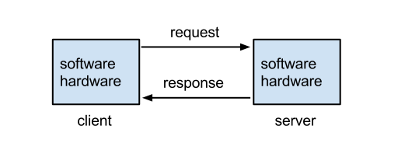

Fig 1.1: client-server model

**1.7 PROGRAMMING LANGUAGES USED**

**Front-end languages used:**

* Html(html5): It is actually a markup language. it is First developed by Tim Berners-Lee in 1990 HTML is short for Hypertext Markup Language. HTML is used to create electronic documents (called pages) that are displayed on the World Wide Web. Each page contains a series of connections to other pages called hyperlinks. Every web page you see on the Internet is written using one version of HTML code or another. HTML is a markup language that web browsers use to interpret and compose text, images, and other material into visual or audible web pages.
* CSS: By itself, HTML is quite plain. HTML does provide some basic style options, but to build a good frontend, developers must have experience with CSS. CSS provides the paint, templates, glitter, buttons, tassel, lights, and many other things that can be used to improve the presentation of a web page. CSS is so commonly used that languages have been built to make writing CSS easier. These languages – like Sass and LESS – are also known as CSS precompiles, but they are simply used to write more efficient and manageable CSS code.

**Back-end:**

Scripting languages used for making Front-end of a web application

* PHP: PHP (recursive acronym for PHP:Hypertext Preprocessor) is a widely-used open source general-purpose scripting language that is especially suited for web development and can be embedded into HTML
* JavaScript: JavaScript is a dynamic computer programming language. It is lightweight and most commonly used as a part of web pages, whose implementations allow client-side script to interact with the user and make dynamic pages. It is an interpreted programming language with object-oriented capabilities.
* jQuery: jQueryis a fast and concise JavaScript Library created by John Resig in 2006 with a nice motto − Write less, do more. jQuery simplifies HTML document traversing, event handling, animating, and Ajax interactions for rapid web development.

**Database management systems used in back-end**

**MySQL:** MySQL is the most popular database system used with PHP. It is the most popular Open Source SQL database management system, is developed, distributed, and supported by Oracle Corporation. With its proven performance, reliability and ease-of-use, MySQL has become the leading database choice for web-based applications, used by high profile web properties including Facebook, Twitter, YouTube, Yahoo! and many more.

The MySQL server software itself and the client libraries use dual-licensing distribution. MySQL is written in [C](https://en.wikipedia.org/wiki/C_(programming_language)) and C++. Its SQL parser is written in yacc, but it uses a home-brewed lexical analyzer. MySQL is offered under two different editions: the open source MySQL Community Server and the proprietary Enterprise Server MySQL Enterprise Server.

Though MySQL began as a low-end alternative to more powerful proprietary databases, it has gradually evolved to support higher-scale needs as well. It is still most commonly used in small to medium scale single-server deployments, either as a component in a LAMP-based web application or as a standalone database server. Much of MySQL's appeal originates in its relative simplicity and ease of use, which is enabled by an ecosystem of open source tools such as phpMyAdmin. In the medium range, MySQL can be scaled by deploying it on more powerful hardware, such as a multi-processor server with gigabytes of memory.

**1.8 DESCRIPTION OF BASIC TAGS & SPECIAL TAGS**

**Basic tags:** Some of the basic tags used are:-

* <!DOCTYPE>: Defines the document type.
* <a>: Defines the hyperlink
* <Body>: Defines the document body.
* <br>: Defines a single line break.
* <button>: Defines a clickable button.
* <div>: Defines a section in document.
* <font>: Defines a font, color and size for text.
* <form>: Defines a html form for user input.
* <h1> to <h6>: Defines html headings.
* <head>: Defines information about the document.
* <img>: Defines an image.
* <link>: Defines the relationship between a document and an external resource.
* <script>: Defines client-side script.
* <style>: Defines style information for a document.
* <table>: Defines a table.

**Special tags:** Some of the special tags used are:-

* <section>: Defines a section in document.
* <article>: element specifies independent, self-contained content.
* <header>: element specifies a header for a document or section.
* <footer>: element specifies a footer for a document or section.
* <nav>:  element defines a set of navigation links.
* <aside>: element defines some content aside from the content it is placed in (like a sidebar).
* <time>: Defines a date/time.

CHAPTER 2

**MINIMAL REQUIREMENT SPECIFICATIONS**

**2.1 Software Requirements:**

* **Languages used :** HTML, CSS, JavaScript, Bootstrap, Ajax, jQuery, PHP
* **Web Server :** XAMPP( Apache Server and MySQL DB)
* **Editor :**Sublime text
* **Web Browser :** Google Chrome/ Mozilla Firefox/ Opera/ IE8
* **Operating System :** Windows, Linux

**2.2 Hardware Requirements:**

* **Processor:** Intel Pentium 3(Minimum 1GHz).
* **RAM :** Minimum of 512MB.
* **Hard Disk:** At least 100MB of free disk space.
* **Input and Output**

**2.3 Functional Requirements:**

With the web application, the admin should be able to

* View tour bookings and their personal details like name, email, phone number, etc.
* View the bill of each customer including package details.
* View the tour status and modify it.
* View the customer status of booking and cancellation.
* Receive feedback from the customer
* Cancel the booking
* View the package details
* Make the payments
* Get registered to book and send feedback to company.

CHAPTER 3

**IMPLEMENTATION**

**3.1 UML Diagram**

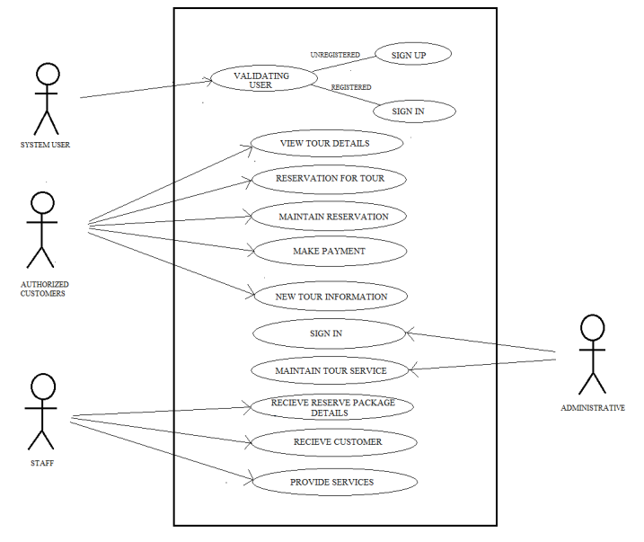

Fig 3.1: UML Diagram

**3.2 Dataflow Diagram**

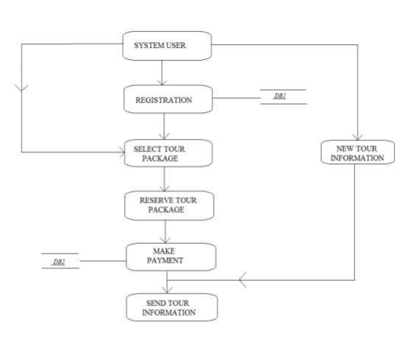

Fig 3.2: Dataflow diagram

**3.3 ER-Diagram**

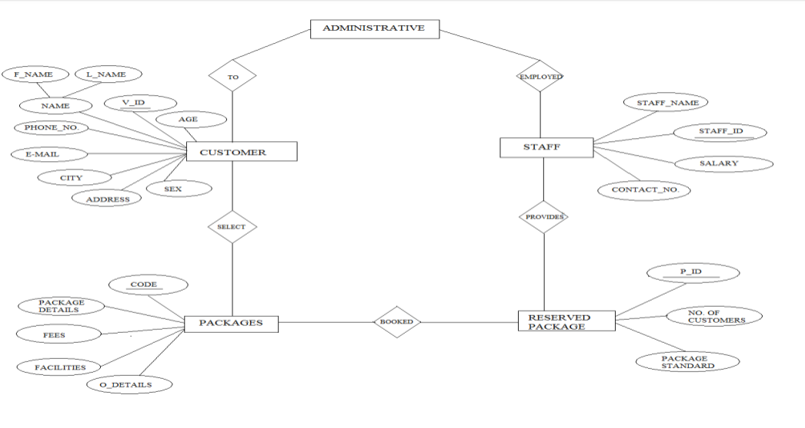

Fig 3.3:ER- diagram

**3.4 Code Snippets**













CHAPTER 4

**SNAPSHOTS AND RESULTS**

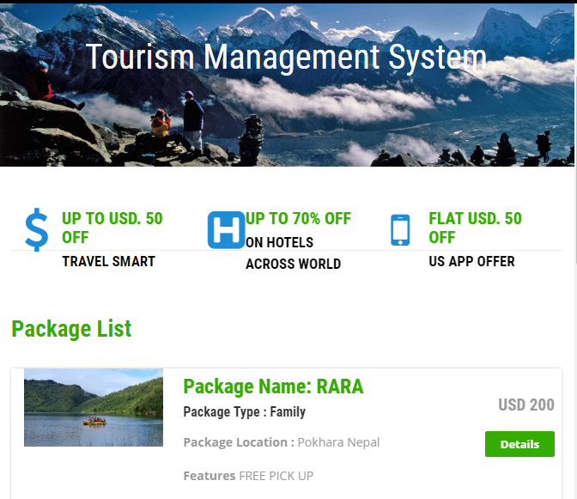

Fig 4.1: Home Page

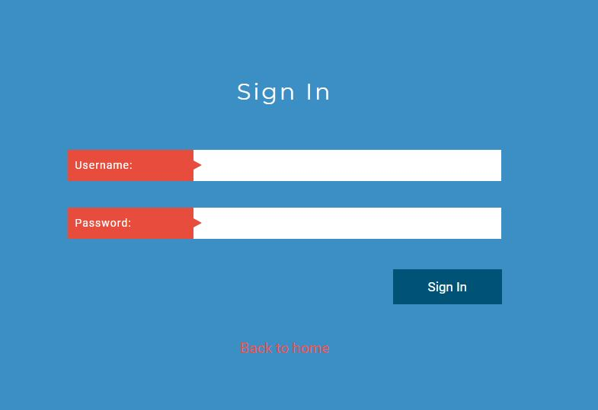

Fig 4.2: Login Page

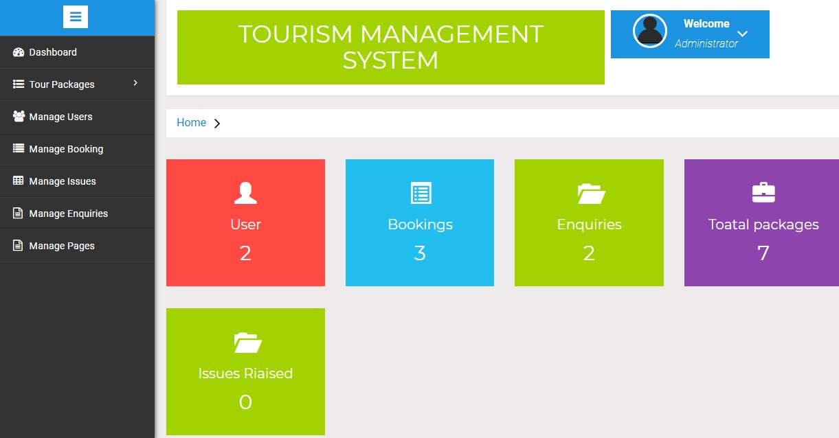

Fig 4.3: Dashboard

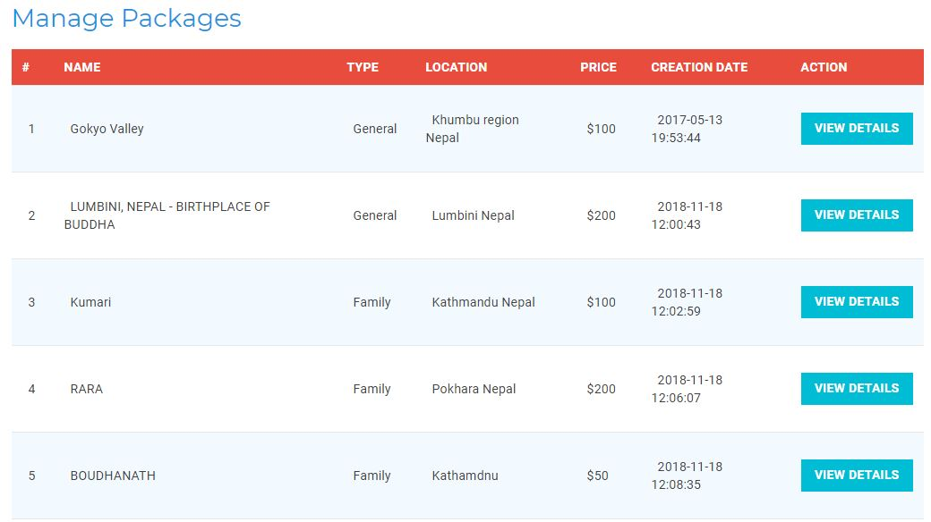

Fig 4.4: Package List (Admin Section)

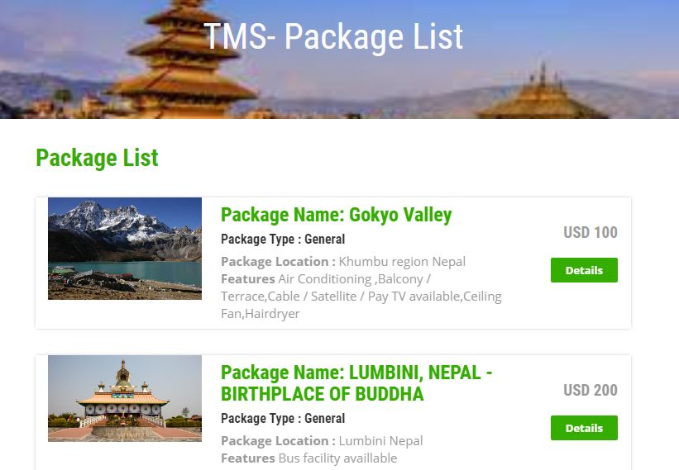

Fig 4.5: Package List

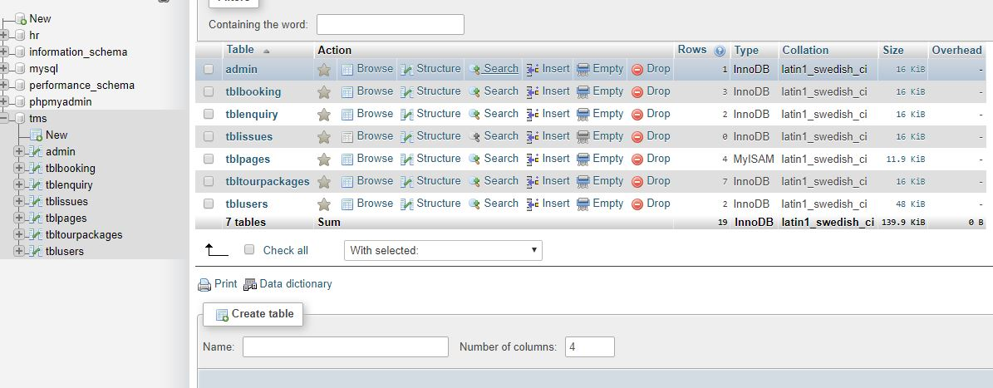

Fig 4.6: Database Table

**CONCLUSION & FUTURE ENCHANCEMENT**

**CONCLUSION**

The following conclusions can be drawn from our system:

* Automation of the system improves the efficiency level.
* It is a friendly graphical user interface when compared to the system that already exist.
* It give authenticate access to the authorized users depending upon their user type.
* It effectively overcomes the delay in communications.
* System security, data security and reliability are the main features.
* The System has adequate scope for modification in future if it is necessary.

**FUTURE ENHANCEMENT**

* Development and launching of Mobile app.
* Refining existing services and adding more service.
* Development of location tracking system.
* Development of user tracking system.
* Development of live customer support.

**BIBLOGRAPHY**

1. Randy Connolly,Ricardo,”Fundamental of web Development”,1st Edition, Pearson
2. https://www.w3schools.com/
3. https://www.youtube.com/watch?v=HODmbzOT288
4. https://en.wikibooks.org/wiki/Web_Programming/Web_and_Web_Programming